Diabetes Disease Prediction Report

Abstract
Diabetes is a chronic metabolic disorder with significant global health implications. Early detection is vital for effective management and prevention of complications. This study applies machine learning techniques to predict diabetes using a dataset of demographic and clinical features. Data preprocessing, exploratory analysis, feature selection, and model evaluation were conducted using Support Vector Machine (SVM) and K-Nearest Neighbors (KNN) algorithms. Feature selection was performed using Random Forest importance scores, and models were evaluated using accuracy and classification metrics. The results demonstrate that focused modeling with selected features can achieve high predictive performance while improving interpretability.

1.0 Introduction
Diabetes is a chronic metabolic disorder that affects millions of people globally. Early prediction and diagnosis are essential for effective management and prevention of complications associated with diabetes. In this study, we developed and evaluated machine learning models to predict the presence of diabetes using patient demographic and clinical features.

2.0 Materials and Methods

2.1 Data Collection
The dataset used in this study was obtained from the file 'diabetes_data_upload (3) (1).csv'. It consists of 17 features, including demographic information (such as age and gender) and various clinical symptoms, with the target variable indicating the presence (Positive) or absence (Negative) of diabetes.

2.2 Data Preprocessing
- Data Loading and Exploration: The dataset was loaded using pandas. Initial exploration was performed using .head(), .info(), and .isnull().sum() to understand the structure and check for missing values. No missing values were found.
- Encoding Categorical Variables: All categorical variables (Yes/No, Male/Female) were encoded into numerical values to facilitate modeling.
- Class Distribution: The dataset was found to be slightly imbalanced, with 320 Positive and 220 Negative cases.

2.3 Exploratory Data Analysis
- Class Distribution: The distribution of the target variable was visualized using a countplot.
- Feature Distributions: Age and gender distributions were analyzed and visualized by class.
- Correlation Analysis: A heatmap was used to examine the relationships between features and the target variable.
- Outlier Detection: Boxplots were used to identify outliers in numerical features.

2.4 Data Splitting
The dataset was split into training and test sets (80/20) using stratified sampling to preserve the class distribution.

2.5 Model Building
Two machine learning algorithms were implemented:
- Support Vector Machine (SVM): Trained using all features and evaluated using accuracy, confusion matrix, and classification report.
- K-Nearest Neighbors (KNN): Trained and evaluated similarly.

2.6 Feature Selection
Feature selection was performed using a Random Forest classifier to rank features by importance. The top 8 and top 4 features were selected for further modeling.

3.0 Results

3.1 Exploratory Data Analysis
- Class Distribution:
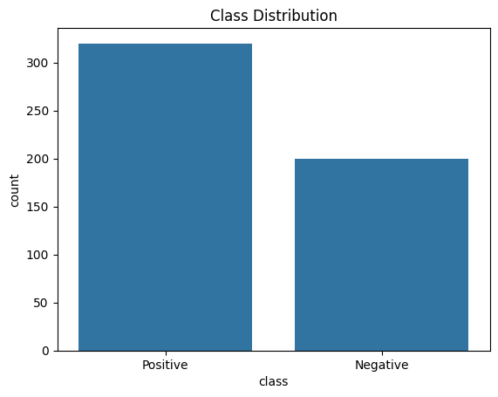
-
Age Distribution by Class:
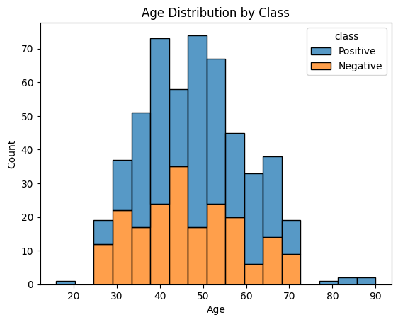
-
Gender Distribution by Class:
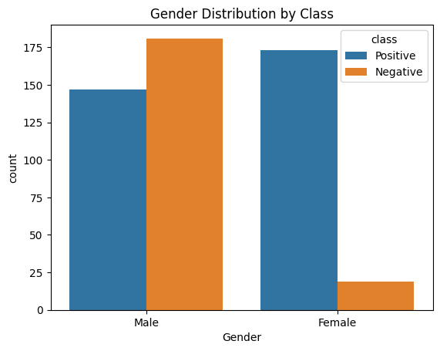
- Correlation Heatmap:
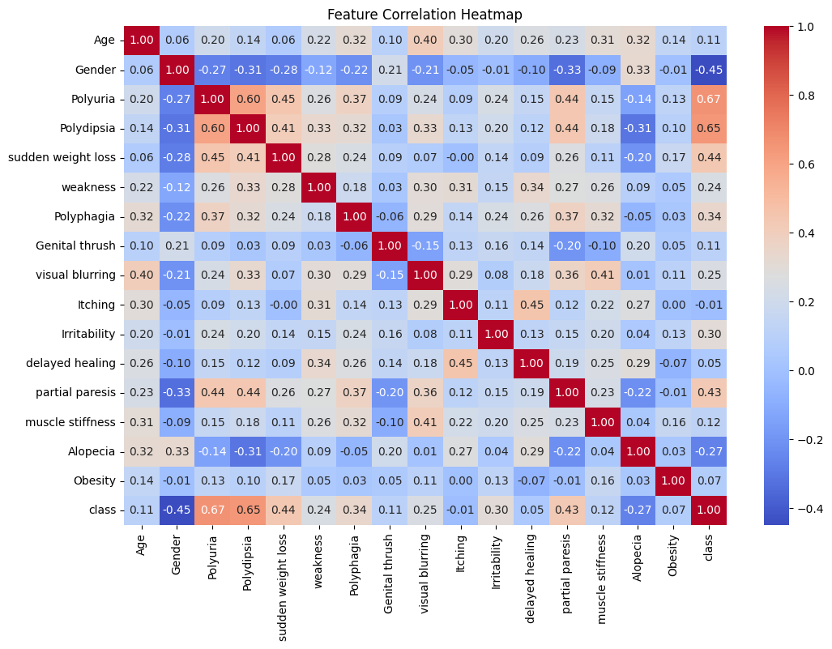

3.2 Model Performance with All Features
- SVM Results:
Confusion Matrix:
[[39 1]
[ 6 58]]
Classification Report:
precision recall f1-score support

0 0.87 0.97 0.92 40
1 0.98 0.91 0.94 64

accuracy 0.93 104
macro avg 0.92 0.94 0.93 104
weighted avg 0.94 0.93 0.93 104

Accuracy: 0.93
- KNN Results:
KNN Confusion Matrix:
[[40 0]
[ 3 61]]
KNN Classification Report:
precision recall f1-score support

0 0.93 1.00 0.96 40
1 1.00 0.95 0.98 64

accuracy 0.97 104
macro avg 0.97 0.98 0.97 104
weighted avg 0.97 0.97 0.97 104

KNN Accuracy: 0.97

3.3 Feature Selection and Focused Modeling
- Feature Importances :
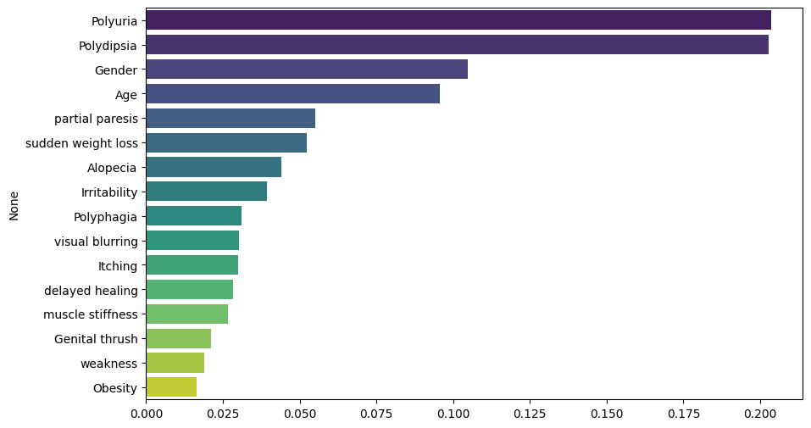
- Top 8 Features:
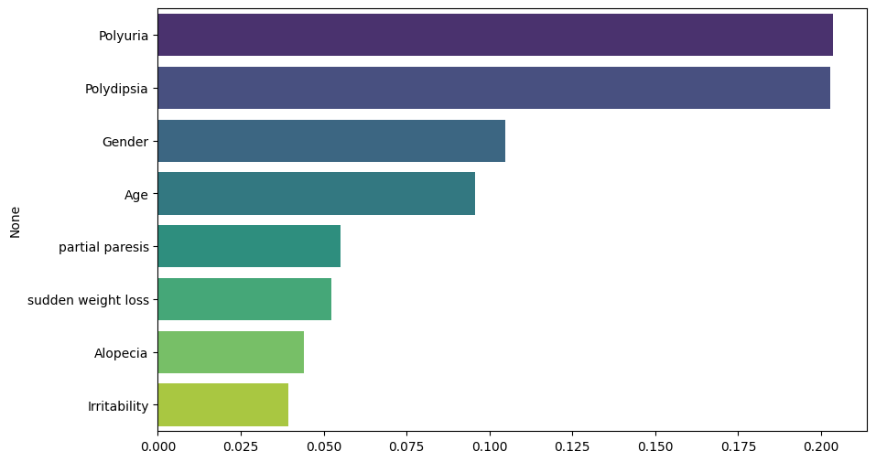
SVM and KNN with Top 8 Features:
- SVM Results:
SVM Confusion Matrix with Top 8 Features:
[[39 1]
[ 5 59]]
SVM Classification Report with Top 8 Features:
precision recall f1-score support

0 0.89 0.97 0.93 40
1 0.98 0.92 0.95 64

accuracy 0.94 104
macro avg 0.93 0.95 0.94 104
weighted avg 0.95 0.94 0.94 104

SVM Accuracy with Top 8 Features: 0.94

- KNN Results:
KNN Confusion Matrix with Top 8 Features:
[[38 2]
[ 6 58]]
KNN Classification Report with Top 8 Features:
precision recall f1-score support

0 0.86 0.95 0.90 40
1 0.97 0.91 0.94 64

accuracy 0.92 104
macro avg 0.92 0.93 0.92 104
weighted avg 0.93 0.92 0.92 104

KNN Accuracy with Top 8 Features: 0.92

3.4 Further Feature Selection: Top 4 Features
- Top 4 Features:
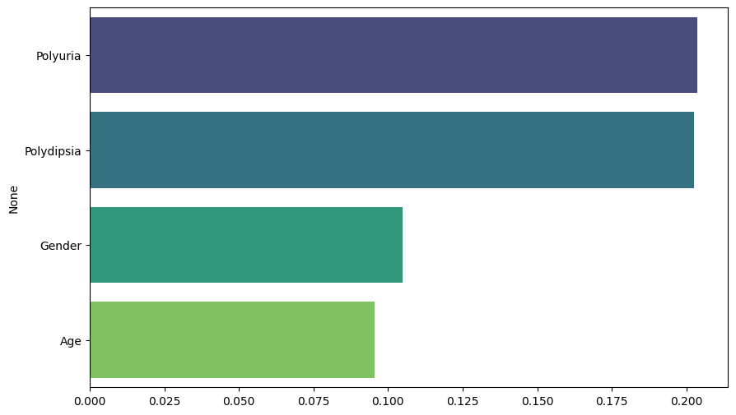

SVM and KNN with Top 4 Features:
- SVM Results:
SVM Confusion Matrix with Top 4 Features:
[[34 6]
[ 2 62]]
SVM Classification Report with Top 4 Features:
precision recall f1-score support

0 0.94 0.85 0.89 40
1 0.91 0.97 0.94 64

accuracy 0.92 104
macro avg 0.93 0.91 0.92 104
weighted avg 0.92 0.92 0.92 104

SVM Accuracy with Top 4 Features: 0.92
- KNN Results:
KNN Confusion Matrix with Top 4 Features:
[[36 4]
[ 5 59]]
KNN Classification Report with Top 4 Features:
precision recall f1-score support

0 0.88 0.90 0.89 40
1 0.94 0.92 0.93 64

accuracy 0.91 104
macro avg 0.91 0.91 0.91 104
weighted avg 0.91 0.91 0.91 104

KNN Accuracy with Top 4 Features: 0.91

4.0 Discussion
The results demonstrate that both SVM and KNN models can effectively predict diabetes using the provided features. Feature selection using Random Forest allowed for the identification of the most impactful predictors, enabling the development of simpler and potentially more interpretable models. The models trained on the top 8 and top 4 features maintained competitive performance compared to those trained on all features, highlighting the value of focused modeling.

5.0 Conclusion
This study successfully applied machine learning techniques to predict diabetes based on demographic and clinical features. Feature selection contributed to model simplification without significant loss of accuracy. Future work may involve exploring additional algorithms, further feature engineering, or addressing class imbalance through advanced sampling techniques.

6.0 References
- UCI Machine Learning Repository
- Scikit-learn documentation
- Seaborn and Matplotlib documentation

